 **Software Requirements Specification Document**

Table of Contents

1. Functional Requirements 3

1.1 Header & Footer 3

1.1.1 Logo 3

1.1.2 Background 3

1.1.3 Status 3

1.1.4 Copyright 3

1.2 Menu 3

1.2.1 Home 3

1.2.2 Profile 3

1.2.3 Register 3

1.2.4 Log in 3

1.3 Homepage & Embedded Viewer 4

1.3.1 Image 4

1.3.2 Arrows 4

1.3.3 Stars 4

1.3.4 Comments 4

1.4 User Profile 4

1.4.1 Points 4

1.4.2 Filter 4

1.4.3 Graph 4

1.5 Retailer Profile 5

1.5.1 Demographics 5

1.5.2 Upload 5

1.5.3 Pictures List 5

1.5.4 Rewards List 5

2. Complete Use Case Diagram 6

3. Detail Use Case Diagrams 7

3.1 Account Registration 7

3.2 User Main Process 8

3.3 User Profile Process 9

3.4 Retailer Picture & Reward Upload 10

3.5 Retailer Profile Process 11

4. System Constraints 12

# 1. Functional Requirements

## 1.1 Header & Footer

### 1.1.1 Logo

* Displayed in the top left corner of the header
* Must be contained within the header background

### 1.1.2 Background

* Frames the logo and menu
* Positioned at the top of the site and forms the top left and right corners
* Constitutes the perimeter of the header as well as the maximum width of the site
* Static fixed display type which is independent from page scrolling
* Height: ~50px
* Color: Grey

### 1.1.3 Status

* Displayed in the top right corner of the header
* Displays user full name
* Displays ‘Welcome’ before the user’s name
* Not displayed if the user is not logged in

### 1.1.4 Copyright

* Display a copyright label ‘c 2014 piqls’ in the bottom center of the layout

## 1.2 Menu

### 1.2.1 Home

* Redirects user to home page

### 1.2.2 Profile

* Checks the user’s account type
* Redirects user to the user profile page for user accounts
* Redirects user to the retailer profile page for retail accounts

### 1.2.3 Register

* Draws a form for registering a keyed pair account (username, password)
* Records account information in a database

### 1.2.4 Log in

* Draws buttons for keyed pair login
* Draws buttons for OAuth login (aka. External login)
* Links to the ‘Register’ page

## 1.3 Homepage & Embedded Viewer

### 1.3.1 Image

* Display an image from a database
* Image is draggable
* When released inside the gutters the image returns to the center
* When released outside a gutter, the image is removed from that side of the screen
* When removed to the left, the “dislike” logic is triggered
* When removed to the left, the “like” logic is triggered
* “likes” and “dislikes” are recorded in a database and points are allotted to the user
* After being liked or disliked a new image is loaded and moved to the center

### 1.3.2 Arrows

* Display left and right arrows to either side of image

### 1.3.3 Stars

* Display 5 grey stars below the image
* Get the average rating from a database and color that many stars yellow
* Users can click a star and record their rating in a database
* After clicking a star, that many stars become colored regardless of the average

### 1.3.4 Comments

* Display a text area input below the stars and databind to a database
* Get existing comments about that image and display them consecutively below the input
* Chronological descending order
* When the image is dragged vertically, older comments can be viewed

## 1.4 User Profile

### 1.4.1 Points

* Display the user’s accumulated point value in the top right corner under the header

### 1.4.2 Filter

* Filters are displayed in the top left corner under the header
* Display a date filter which specifies a comparison operator and one date
* Comparison operator includes: <, >, =, <=, >=
* Display a dropdown representing a category filter

### 1.4.3 Graph

* Display a vertical bar graph which spans the width of the page
* The graph displays data about the user’s votes based on the selected filters
* Each bar has two layers and represents one retailer
* One layer is the user’s votes while the other layer is the global average for that retailer
* The graph displays the top 5 retailers according to the filters
* Bars can be clicked to display the retailer’s “Rewards List”
* Clicking a “Rewards List” icon will pop up a printable coupon
* Upon clicking a reward, that many points are deducted from the user
* Warn the user before clicking that they are about to spend points

## 1.5 Retailer Profile

### 1.5.1 Demographics

* Display filter inputs from the top left under the header
* Dropdown for demographic type (e.g. age)
* Comparison operator for the following input (<, >, =, <=, >=)
* Text box input for a value (e.g. 40)
* Display a date filter which specifies a comparison operator and one date
* Display a pie graph which spans the width of the page
* Each section represents one “Picture” and its ratings

### 1.5.2 Upload

* A text box input is displayed in the top left corner under the header for a name
* Next to that is a dropdown to specify “Picture” or “Reward”
* Next to that is an upload input which accepts image files only
* Max size: 4 mb
* Uploaded images are stored in a database
* Uploaded “Pictures” are added to the “Pictures List”
* Uploaded “Rewards” are added to the “Rewards List”

### 1.5.3 Pictures List

* Display a button to collapse the picture list
* Display a list of retailer’s images categorized as pictures
* Each list item displays the image on the left and metadata on the right
* Text Box metadata for changing and displaying the name
* Autocomplete metadata for tagging a category
* Spinner metadata for tagging a point value

### 1.5.4 Rewards List

* Display a button to collapse the rewards list
* Display a list of retailer’s images categorized as rewards
* Each list item displays the image on the left and metadata on the right
* Text Box metadata for changing and displaying the name
* Dropdown metadata for selecting a reward type
* Spinner metadata for tagging a point value

### 

# 2. Complete Use Case Diagram

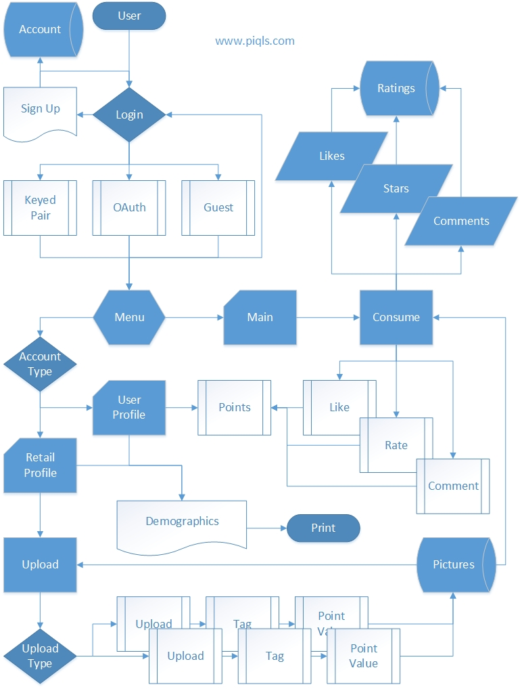

# 3. Detail Use Case Diagrams

## 3.1 Account Registration



## 3.2 User Main Process



## 3.3 User Profile Process



## 3.4 Retailer Picture & Reward Upload



## 3.5 Retailer Profile Process



# 4. System Constraints

